ACCOUNT OPENING PROCESS FLOW

ICCD have formulated Account Opening Checklist (Annexure O) and will update the checklist time to time to make sure the list is up to date and in line with all internal as well as external regulations.
Account Opening Checklist will be source document for performing all kinds of internal branch review/inspection regarding account opening and maintenance. Relationship Managers/Relationship Associate needs to collect the account opening documents according to the latest checklist applicable.

- For Corporate Customer account opening process will be as follows;
Upon receipt of documents form customer, the RM/RA will initiate KYC in BRAINS and forward it to ICCD. At the same time relationship manager will share hardcopy/original documents with Banking Department. RM/RA will confirm ICCD regarding original/hardcopies submitted to Banking Department by means of comments in BRAINS.
Banking Department will 1). Check the completeness of documents in line with the checklist and as per their departmental requirements and; 2) Give suggestions of changes/replacement/rectification on the contents of documents if any to Compliance Department.
Banking Department and ICCD will review documents independently as per their areas at the same time, and ICCD will wait for BD review/comments/discrepancies before further processing the case in Brains system (i.e. either mark discrepant and return the request to relationship manager or forward it to next level approver).
RM/RA will coordinate with customer to rectify/remove all the discrepancies (either identified by Banking or by ICCD) which are communicated by Compliance Department through the BRAINS system.
After all the discrepancies are rectified/ removed; the ICCD will approve customer's KYC in Brains subject to banking department confirmation for discrepancies highlighted by them. Upon KYC approval in Brains, Banking will initiate account opening in core banking system.
To illustrate the process, below is graphical representation of process flow of corporate high risk customer;
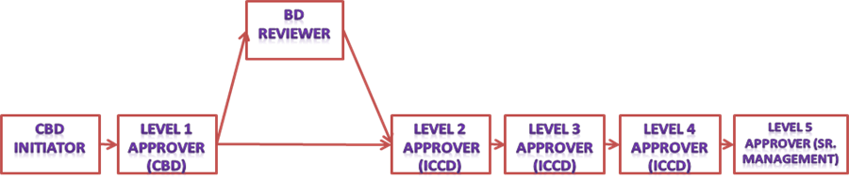
- For individual Customer account opening process will be as follows;
Client facing staff will collect documents as per latest account opening checklist and initiate KYC on BRAINS after performing scrutiny (subject to removal of all discrepancies) as per the their departmental requirements.
ICCD will review KYC as per their area and process for approval (and if there are any discrepancies then ICCD will return KYC and BD will rectify and resend KYC to ICCD).
Once KYC has been approved by ICCD, BD will initiate account opening into core banking system.

To illustrate the process, below is graphical representation of process flow of individual high risk (PEP) customer;

In light of directives received form SBP, no services to proscribed individuals/entities should be provided and it will be responsibility of account opening officer and relationship manager to ensure individual or entity who’s account is being opened or maintained is not in proscribed list and undertaking of same should be provided on AOF.

