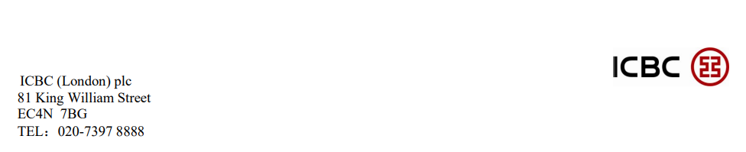**BUS - Nearest Bus Routes**

King William Street 21 43 133 141 N21

Bank 21 26

Cheapside 8 25

Cannon Street 15 17

**RAIL - Nearest rail stations**

Cannon Street London Bridge Liverpool Street

Moorgate Fenchurch Street

**UNDERGROUND - Nearest rail station**

Bank: Central, DLR, Northern, Waterloo & City Line (Exit 6)

Monument/Cannon Street: Circle, District Line (Towards King William Street Direction)

London Bridge: Jubilee, Northern Line (Towards London Bridge)

**PARKING - Public car parks are available at**

NCP London Vintry Thames Exchange: Bell Wharf Lane, London, EC4R 3TB 24 Hours

Baynard House Car Park: 133 Queen Victoria Street, London, EC4V 4BQ 24 Hours

Tower Hill Car Park: 50 Lower Thames Street, London, EC3R 6DT 24 Hours