Digital Token Frequently Asked Questions (FAQ)

Q1：Why set up ICBC Digital Token?

A1：Set up your Digital Token to continue Mobile Banking/Internet Banking transaction seamlessly. With Digital Token, you no longer face the hassle of having to bring along your physical token as it replaces all SMS OTPs or authentication through a seamless and secured journey with just your mobile phone.

Q2: Will I be able to continue using the Internet or Mobile Banking services if I do not set up ICBC Digital Token?

A2: Yes. You may continue to use your physical token or SMS OTP for all Internet and Mobile Banking service.

Q3: Is ICBC Digital Token applicable for the Internet Banking?

A3：Yes. Customers who have already enrolled in DT through Mobile Banking will be required to use DT authentication when accessing Online Banking and performing transactions.

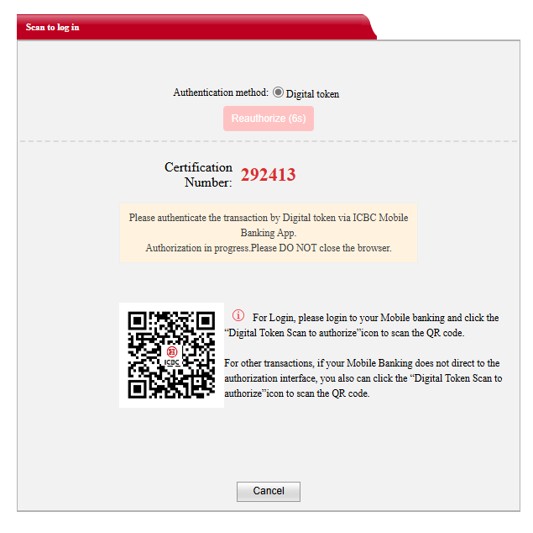
During the Online Banking login authorization process, the following flow will apply:

1.Need the DT user self-initiated login to Mobile Banking, click on “Digital token Scan to authorize” icon and scan the QR code which displayed on Internet Banking to do authenticate.
During the Online Banking transaction authorization process, the following flow will apply:

1. A push notification will be sent to the customer’s registered mobile device where the ICBC Mobile Banking App is installed. If authorization takes longer than 10 seconds, click "Re-authorize" on the Online Banking screen to restart the process.

Customer will receive the notification, click on the notification which will direct the customer to log into the Mobile Banking App to view the pending authorization transaction detail and to approve the transaction.

Once authentication is successfully completed in the Mobile Banking App, the corresponding login or transaction in the Internet Banking will be approved and processed.

If the Mobile Banking does not direct to the authorization interface, customers can do authenticate via QR code:

On the Online Banking authentication page, the customer may scan the displayed QR code shown in the Internet Banking by using the Mobile Banking App-“Digital token Scan to authorize” icon.
By scanning the displayed QR code using the Mobile Banking App, customers are redirected to the DT authentication interface to approve the login or transaction on Mobile banking.

Q4: How to set up ICBC Digital Token?

A4：Set up using your Physical Token and SMS OTP. After setting up, Digital Token is available for use after 12 hours cooling period.

Step 1: Step 2: Step 3:
Login your Mobile Banking Read and agree the T&C Enter the verification code generated
OTP from the physical token
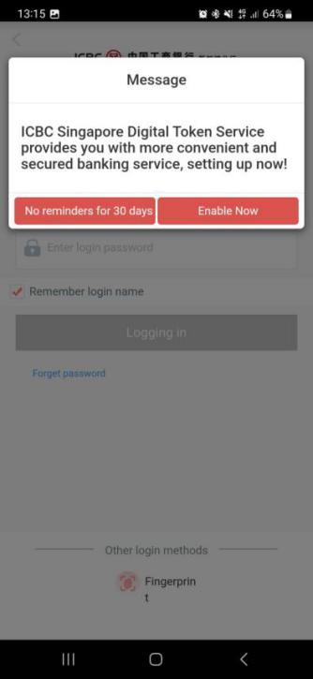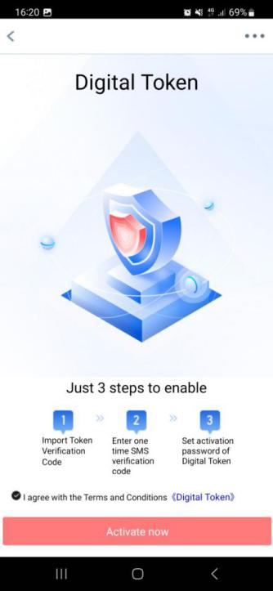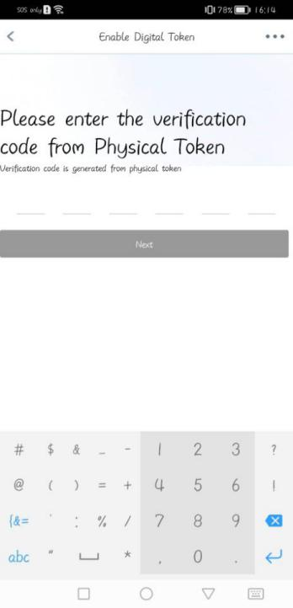

Step 4: Step 5:
Enter SMS OTP for 2nd verification. Set a 6 digit number as Digital Token Pin
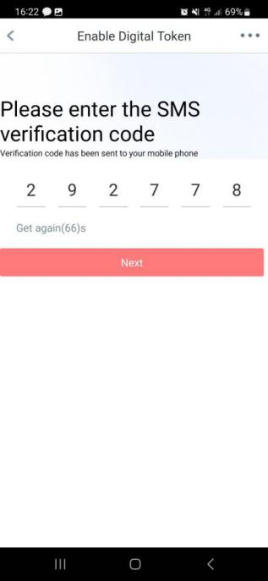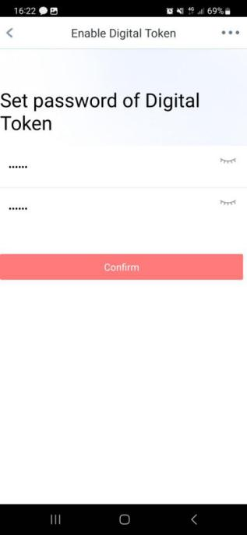

Q5: How do I authorize Mobile Banking transaction using ICBC Digital Token?

A5: Key in Digital Token 6 digit PIN and press confirm. Please note that some of the transactions may require SMS OTPs as well.

Q6: I forgot my ICBC Digital Token Pin. What should I do?

A6: 1) Tap on “All” under Financial Assistant
- Tap on “Digital Token Setting”
- Tap on “Reset Digital Token”
- Re-Set up your digital token by using your Physical Token and SMS OTP and Digital Token is available for use after 12 hours cooling period.

Q7: Are there any charges for ICBC Digital Token?

A7: No, there is no additional charges for using Digital Token.

Q8: How do I change my ICBC Digital Token Pin?

A8: 1) Tap on “All” under Financial Assistant
- Tap on “Digital Token Setting”
- Tap on “Change Password”
- Need to key in the Old Pin number and New Pin number

Q9: I’ve changed my mobile device. Do I need to set up my ICBC Digital Token again?

A9: Yes. The digital token on your old device will be removed once you do so.

Q10: What if my ICBC Digital Token Pin is locked due to exceeded pin tries?

A10: For security reasons, your ICBC Digital Token will be disabled automatically. You will need to set up your ICBC Digital Token again. (Please refer to Question 4 above).

Q11: Can I set up my ICBC Digital Token on multiple mobile device?

A11: You can only set up your ICBC Digital Token on one mobile device. If you set up ICBC Digital token on a separate mobile device, the previous set up will be disabled.

Q12: What if I lose my mobile device?

Q12: Please contact ICBC hotline at 65-6369 5588 immediately and our Customer Service Representative will be able to disable the Online Banking service.

